**Thermodynamic analysis**

From its outlet, this reactor generates a very high temperature heat of approximately 1150 K (876C). This output heat could be useful for generating electricity and could be used in other applications if treated appropriately, which is the goal of most current nuclear power plants (NPP) and their designs. This nuclear power plant will not just generate electricity; it will use the heat it produces in industrial applications, such as the generation of hydrogen or in desalination.

This section will cover the design and analysis of the energy cycles with regard to their safety and security. Because this reactor will be marketed internationally, and different customers have their own individual needs, two main versions of the energy cycle were designed and analyzed and each version includes two sub-versions. We aim to create a flexible design that suits a variety of customers. The main goals of the power cycle’s design is to have net plant efficiency at 50%, to use the NPP for industrial applications, and be an inherently safe and secure NPP.

**Version 1:**

Version 1 has three main loops. The primary loop is a direct Brayton cycle where the reactor is the heat source. The second loop is the Rankine cycle that is connected to the primary loop by a heat exchanger. The third loop is where the industrial application lies. It will be connected by a heat exchanger from the primary loop. The type of industrial application will determine its location in the primary loop, since some need very high temperatures to operate while others do not.

The fluid (helium) moves from the output of the reactor at a very high temperature to the gas turbine to generate the electricity. Then, the low-temperature and low-pressure flow enters a recuperator, which is a specific gas heat exchanger that is used to recover the heat from the gas turbine in order for it to be used again. Afterwards, it enters another type of heat exchanger, which is an evaporator, and then it goes to a compressor. From the compressor, the fluid (which now has a high pressure) enters the inlet of the reactor. From the evaporator heat exchanger, water is a type of flow that can be boiled to generate steam. The steam enters a generator to generate electricity. Then, a condenser that is connected to a cooling power condenses the steam into water. A pump then sends the recovered water back to the evaporator again.

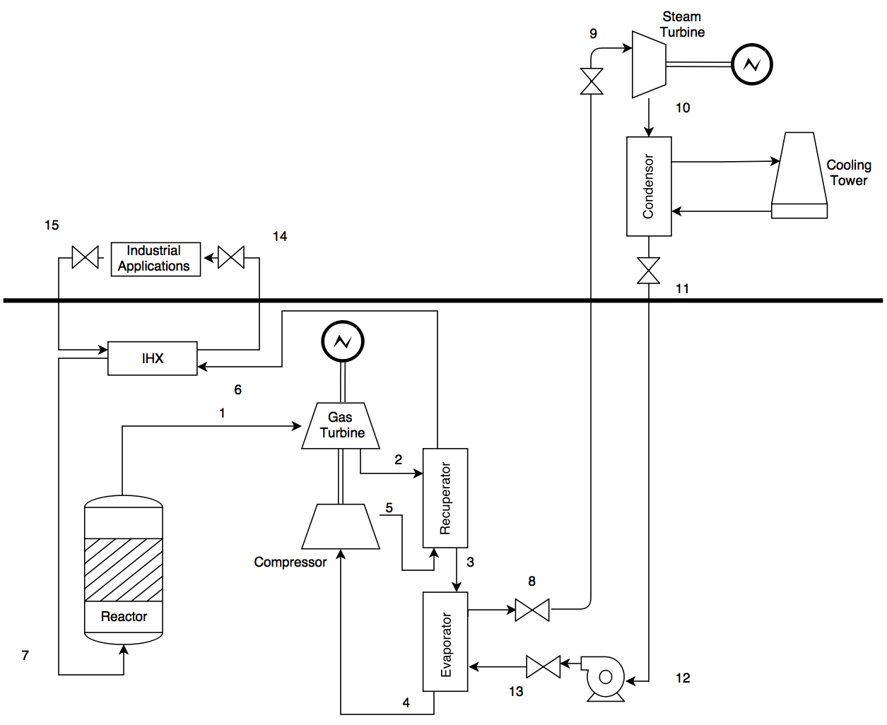

**Figure #.1: Version 1 of the power cycle, where the bold line is the limit of the ground**

**Safety**

It is crucial to operate a nuclear power plant with an inherent safety design. In this case, this was achieved by taking multiple safety features into account, such as:

* Reduction of the radioactive loops as much as possible

Loops 2 and 3 are non-radioactive loops. They are connected to heat exchangers, so the fluid is a non-radioactive flow. This will reduce the potential for causing injury to workers who accidentally touch the flow while doing maintenance or repairing the pipes. Loop 1 will also be a non-radioactive loop since helium is a noble gas and does not become radioactive. However in the interests of safety, loop 1 will be considered a radioactive loop. The worker in the first loop will have to wear special clothes to prevent him or her from making contact with any radioactive materials by mistake.

* Maintenance and accidents

For the maintenance of loops 2 and 3, or in the case that a pipe is broken or leaking, valves are located at each output and input of the heat exchangers and can be closed either manually or automatically from the control room while the reactor and the primary loop continue to operate. This will prevent shutting the reactor down unnecessarily. In this version, any accident or major maintenance of the primary loop requires the reactor to be shut down first. However, this will be further clarified in version 2.

By installing the reactor’s core underground, any major accidents will be less dangerous for the public than they would be if it were installed aboveground since radioactive material has difficulty on ground.

* The locations of each loop

Since the reactor is designed to be underground, the primary loop will be underground as well. However, the second and third loops will be aboveground. If the power plant runs into a major accident and the workers need to evacuate the facility, it will be easy for the aboveground workers to exit as quickly as possible. Since there will be relatively few underground workers, their evacuation will also be quicker than it would be if all the workers were located underground.

**Security and safeguards**

* The locations of each loop

Access to the primary loop, which contains the reactor, will be limited to the people that are either working on the reactor or the gas turbine, and may include some workers from the second loop. As parts of the second loop are located underground, partial access will be given to steam turbine maintenance workers. The industrial application will be aboveground and its workers will not have any access to the underground loops. By limiting the workers’ access to the underground portions, the reactor will be more secure and the number of people who are able to enter the underground sections will be limited and widely known. From the perspective of preventing terrorism, placing the reactor underground and limiting access to it will also limit potential threats to the facility. Moreover, the aboveground systems will be surrounded by materials that can protect them from explosions or airplane crashes in the style of the 9/11 attacks.

* Detectors

Detectors will be installed at each access point to the underground areas with an automatic door lock. If any materials were to be stolen, the doors would be locked and alarms would be activated.

* Cameras

A security camera system will be installed in most parts of the loops, both underground and aboveground.

**Calculations**

For this design, only version 1 was analyzed and all of its parameters were calculated. Each loop was separately analyzed and calculated and then they were combined.

*Brayton cycle:*

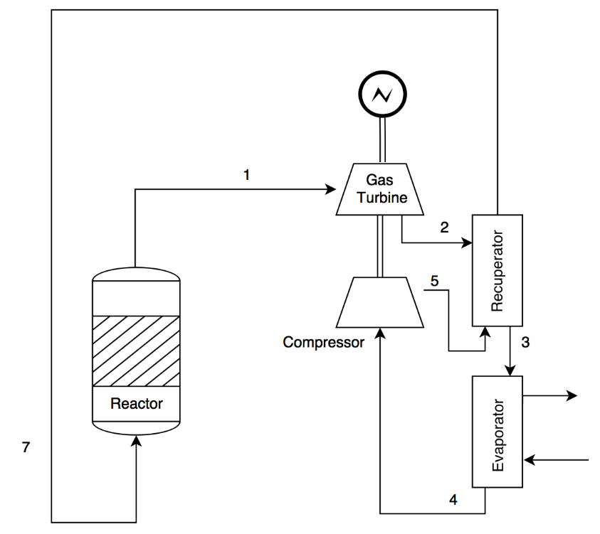

**Figure #.2: The Brayton cycle**

The following parameters are given from the thermohydraulic team:

|  |  |
| --- | --- |
| Parameters (Unit) | Value |
| Reactor outlet temperature (K) | 1150 |
| Reactor inlet temperature (K) | 823 |
| Mass flow rate (Kg/sec) | 424 |
| Outlet pressure (MPa) | 15 |
| Reactor power (MW) | 623.4 |

**Table #.1: The parameters from the thermohydraulic team**

Also, the goal is to have a net plant efficiency at 50%. For this cycle, the goal efficiency was set as a 35% while the remaining 15% will be from the steam cycle. The following equations were studied to generate a Matlab code to calculate all the other parameters.

$$r_{p}=\frac{p_{1}}{p_{2}}=\frac{p_{7}}{p_{4}}$$

Where $r_{p}$ is the pressure or compression ratio of the cycle.

$$η=\frac{\dot{W_{T}}-\dot{W_{CP}}}{Q_{out}}\left[1-\frac{1}{{\left(r_{p}\right)}^{γ-\frac{1}{γ}}}\right]$$

Where $η$ is the Brayton nuclear plant thermodynamic efficiency, $\dot{W_{T}}$ is the work at the turbine and $\dot{W_{CP}}$ is the work at the compressor, $Q_{out}$ is the heat from the reactor and,

$γ=\frac{C_{p}}{C_{v}}$

Also the work at the turbine ( or at the compressor) can be defined as,

$$\dot{W_{T}}=\dot{m} C_{p} T_{1}η$$

And,

$$\dot{W_{T}}=\dot{m} C_{p} (ΔT)$$

Moreover, an efficiency of the gas turbine and the compressor were assumed to be approximately 90%.

After run the code, this table will summarize the main parameters in the gas cycle.

|  |  |
| --- | --- |
| Parameters (Unit) | Value |
| Reactor outlet temperature (C) | 877 |
| Reactor inlet temperature (C) | 550 |
| Gas turbine inlet temperature (C) | 877 |
| Gas turbine outlet temperature (C) | 474 |
| Compressor turbine inlet temperature (C) | 246 |
| Compressor turbine outlet temperature (C) | 550 |
| Gas turbine inlet pressure (MPa) | 15 |
| Gas turbine outlet pressure (MPa) | 5.1 |
| Turbine and compressor efficacy (%) | 90 |
| Net cycle efficiency (%) | 35 |
| Electrical output (%) | 205 |

**Table #.2: Summary of the main parameters in the gas cycle**

The temperature-entropy plot of this cycle is:

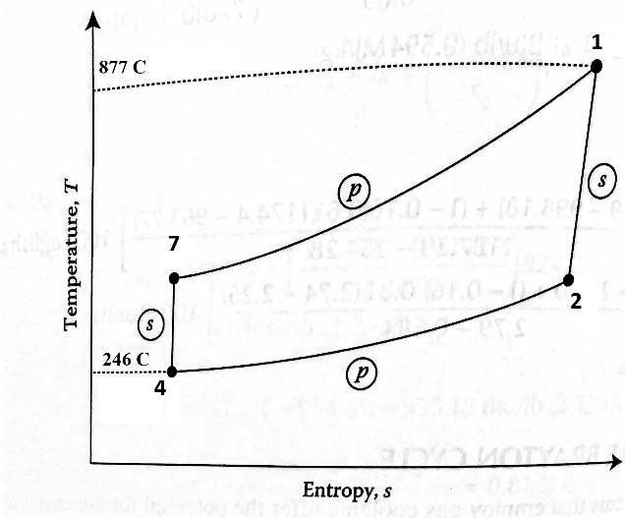

**Figure #.3: Temperature-entropy plot for the gas cycle**

*Rankine cycle:*

This is a cycle that converts the heat from the steam fluid to generate electricity.

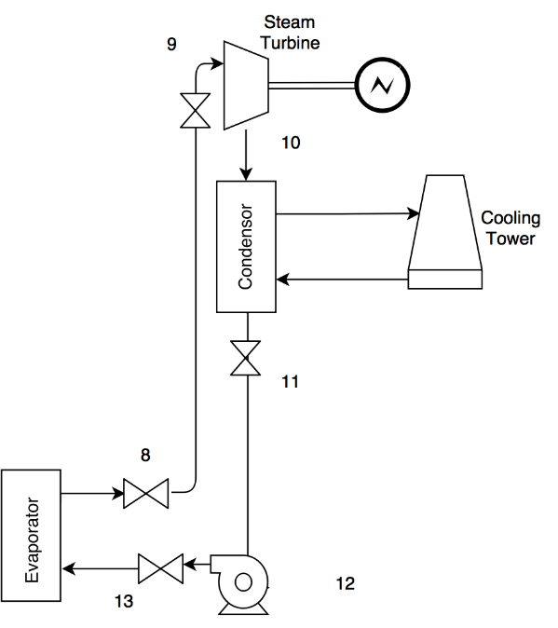

**Figure #.4: The Rankine cycle**

The inlet temperature to the steam generator from the evaporator is 340C (613K). Two major assumptions are that the mass flow rate is 155kg/sec and the pressure is 7.7 MPa. Also, the pumping work is negligible. The following equations are used to determine the other parameters, taking into account a 15% of the thermal power, 600MW, is needed to generate the electricity from this cycle.

$$W=m\left(h_{9}-h_{10}\right)=\dot{m} C_{p} (ΔT)$$

Where h9 is enthalpy at inlet temperature and pressure of the steam turbine. Its unit is kJ/kg.

Also, the thermal efficiency of the Rankine cycle is,

$$η=\frac{W_{turbine}-W_{pump}}{Q_{reactor}}=\frac{\left(h_{9}-h_{10}\right)-\left(h_{13}-h_{12}\right)}{\left(h_{9}-h_{13}\right)}≈\frac{h_{9}-h_{10}}{h_{9}-h_{12}}$$

The following table illustrates all the parameters in the steam cycle.

|  |  |
| --- | --- |
| Parameters (Unit) | Value |
| Steam turbine inlet temperature (C) | 340 |
| Steam turbine outlet temperature (C) | 46 |
| Pumping outlet temperature (C) | 48 |
| Mass flow rate (Kg/sec) | 155 |
| Steam turbine/evaporator efficiency (%) | 90 |
| Net power efficiency (%) | 15 |
| Net power (MW) | 89.043 |

**Table #.3: Summary of the main parameters in the steam cycle**

The Rankine S-T plot is shown in,

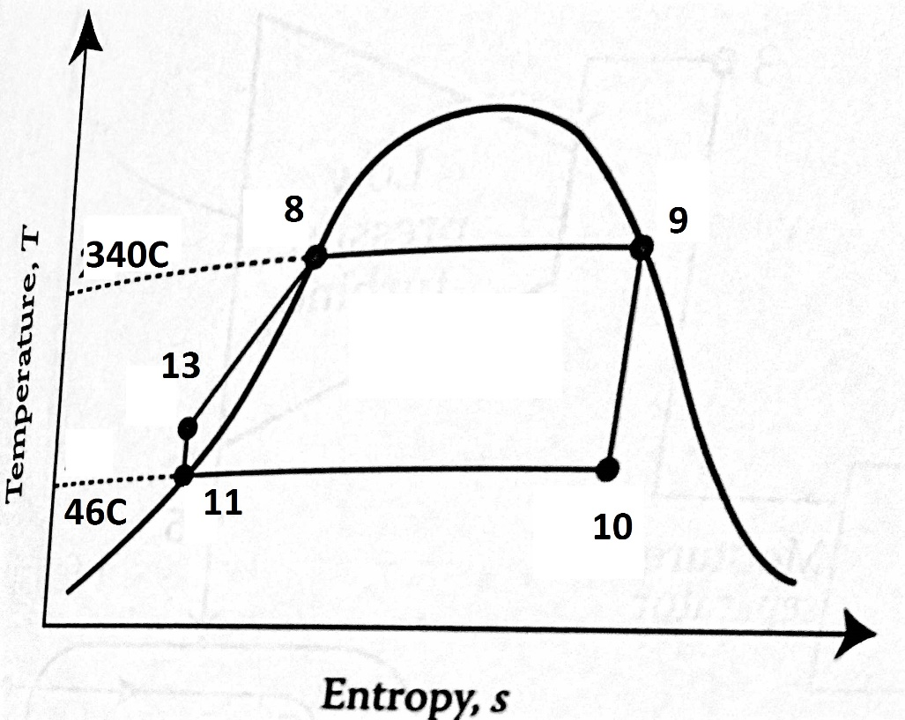

**Figure #.5: Temperature-entropy plot for the steam cycle**

*Industrial applications*

There are many applications that can be adopted by this nuclear power plant, such as the production of hydrogen or desalination. Each application needs a specific type of heat and there are two main places in the cycle at which we can install it. If the application needs a very high temperature, a heat exchanger will be placed directly after the output of the reactor, and if the application needs a high temperature, but not too high, the heat exchanger could be placed before the inlet of the core. The type of the industrial application will depend on the customer’s needs.

**Version 2**

Version 2 of the power cycle is a closed cycle. All the gas and steam turbines and industrial applications are connected to the primary loop with separate heat exchangers.

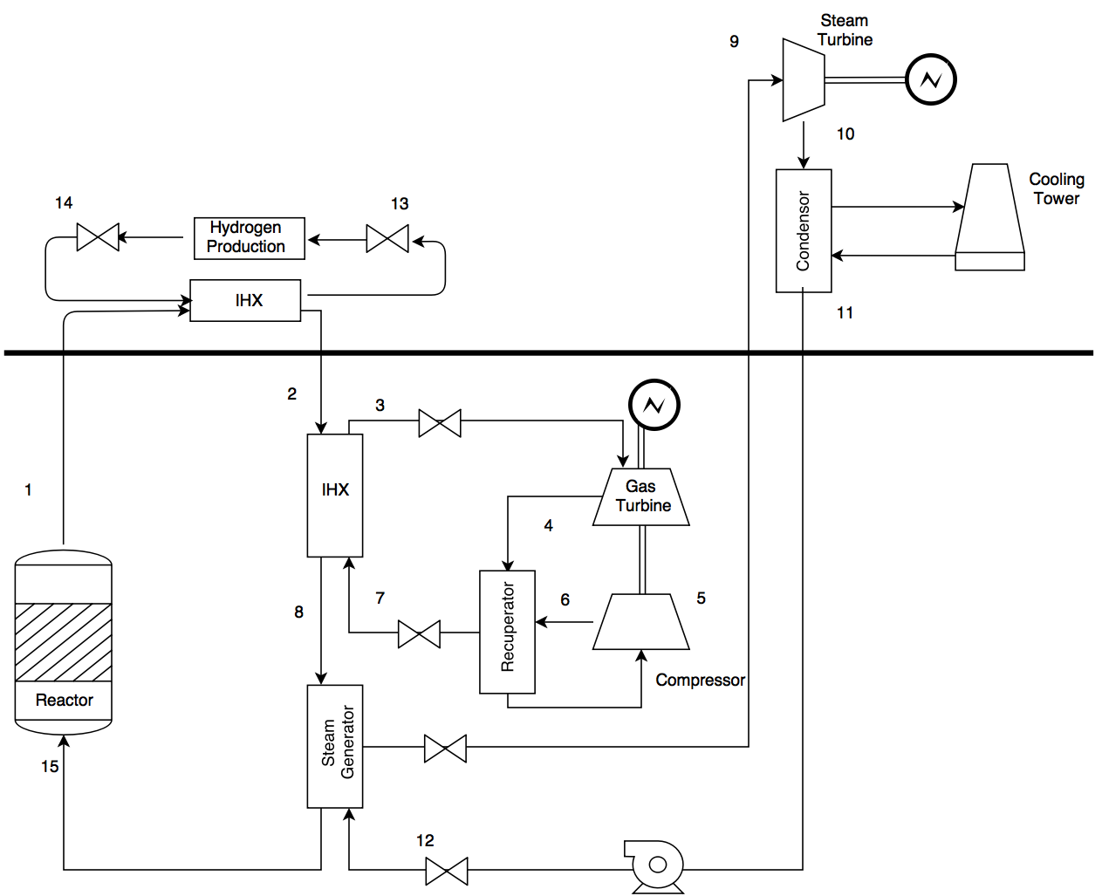

**Figure #.6: Version 2 of the power cycle**

This version has many features. From a safety perspective, the heat exchangers with valves make it easy for the maintenance workers to repair each part of the cycle without necessitating a shutdown of the reactor. Consequently, the reactor will not be affected by damage to the pipes. All the loops, except the primary loop, will be considered non-radioactive.

This version requires further investigation. For example, calculations, such as pressure drops and the temperatures for both the gas and steam cycles need to be defined and carried out. Furthermore, if all the cycles are closed, a cooler needs to be installed before the flow inlet to the reactor. What will happen if the gas turbine, for instance, is closed to the steam turbine? Would we need to install a cooler if the gas turbine shuts down? Both of these questions should be answered and analyzed in future studies.